**5.1 Structural Lipids**

* Insoluble in water and soluble in nonpolar organic solvents

Phospholipids

* Amphipathic and form the bilayer of biological membrane
* Contain a hydrophilic (polar) head group and hydrophobic (nonpolar) tails
  + The head group is attached by a **phosphodiester linkage** (contribute mainly to function)
  + More saturated fatty acids → more rigid (contribute mainly to structure, and partly function depending on the degree of unsaturation)

Glycerophospholipids

* Phospholipids that contain a glycerol backbone

Sphingolipids

* Contain a sphingosine or sphingoid backbone

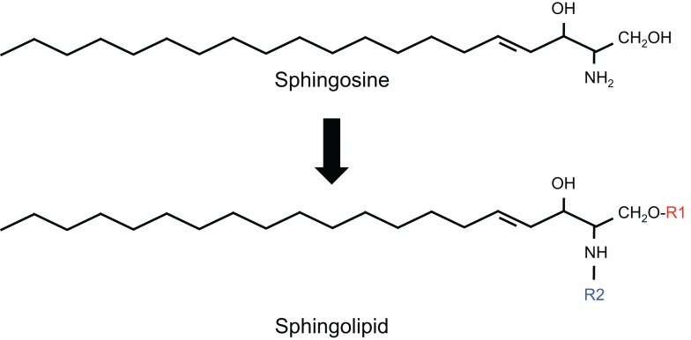

1. Sphingophospholipids (many but not all)
   1. Sphingomyelins
      1. Major class of sphingophospholipids and contain a phosphatidylcholine or phosphatidylethanolamine head group
      2. Major component of the **myelin sheath**
2. Glycolipids
   1. Glycosphingolipids (attached to **sugar moieties** instead of a phosphate group)
      1. Cerebrosides
         1. Have one sugar connected to sphingosine
      2. Globosides
         1. Have two more sugars connected to sphingosine
   2. Gangliosides
      1. Contain **oligosaccharides** with at least one terminal *N-acetylneuraminic acid* (NANA; also called sialic acid)

Waxes

* Esters of long-chain fatty acids with long-chain alcohols
* Used as protection against evaporation and parasites in plants and animals

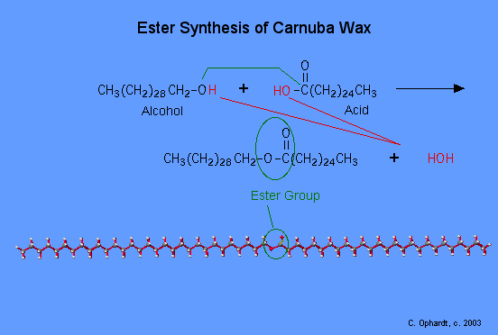

**5.2 Signaling Lipids**

Terpenes and Terpenoids

* Terpene = odiferous steroid precursors made from isoprene (five-carbon molecule)
* 1 terpene unit = monoterpene = 2 isoprene; diterpene = 4 isoprene, …
* Terpenoids = isoprenoids = derivative of terpenes via oxygenation or backbone rearrangement → similar odorous characteristics

Steroids

* Metabolic derivatives of terpenes
* Functionality is determined by:
  + Oxidation status of the rings
  + Functional groups they carry
* Contain three cyclohexane rings and one cyclopentane ring

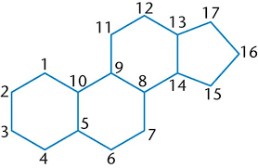

1. Steroid hormone
   1. Have high-affinity receptors
   2. Work at low concentrations
   3. Affect gene expression and metabolism
2. Cholesterol
   1. Important to membrane fluidity and stability
   2. Serves as a precursor to a host of other molecules e.g. steroid hormones, bile acids, and vitamin D

Prostaglandins

* Autocrine and paracrine signaling molecules that regulate cAMP levels
* Have powerful effects on:
  + Smooth muscle contraction
  + Body temperature
  + The sleep-wake cycle
  + Fever and pain

Fat-Soluble Vitamins

* A vitamin is an essential nutrient that cannot be adequately synthesized by the body and therefore must be consumed in the diet
* Commonly divided into:
  + Fat-soluble vitamin (can accumulate in stored fat)
  + Water-soluble vitamin (excess are excreted through the urine)

1. Vitamin A (carotene)
   1. Metabolized to **retinal** for vision, and **retinoic acid** for gene expression in epithelial development
2. Vitamin D (cholecalciferol)
   1. Metabolized to **calcitriol** in the kidneys → increases calcium and phosphate absorption → promoting bone formation
   2. Deficiency in Vitamin D causes rickets (underdeveloped, curved long bones + impeded growth in children)
3. Vitamin E (tocopherols)
   1. Act as biological antioxidants
   2. Destroy free radicals, preventing oxidative damage
4. Vitamin K (phylloquinone and menaquinones)
   1. Important for formation of prothrombin, a clotting factor (‘**Koagulation’**)
   2. Performs post-translational modifications on a number of proteins, creating calcium-binding sites

**5.3 Energy Storage**

Triacylglycerols (triglycerides)

* Preferred method of storing energy for long-term use
  + Carbon atoms of fatty acids are more **reduced** than those of sugars → gives **twice as much energy per gram** during oxidation
  + Very **hydrophobic** → do not draw in water and do not require hydration for stability → **decrease weight**, esp in comparison to hydrophilic polysaccharides
* Adipocytes = storage of large triacylglycerol deposits by animal cells

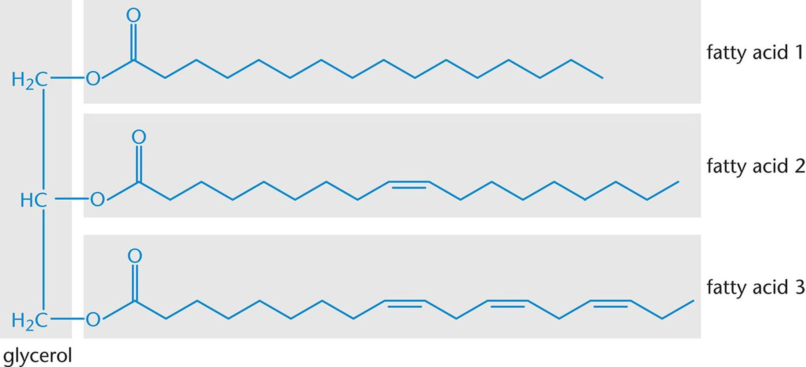

Free Fatty Acids and Saponification

* Free fatty acids = unesterified fatty acids with a free carboxylate group, and travels in the bloodstream
* Salts of free fatty acids are soaps and can be synthesized in saponification
* Saponification = ester hydrolysis of triacylglycerol using a strong base
* Soaps act as surfactants, forming micelles
  + A micelle can dissolve a lipid-soluble molecule in its fatty acid core, and washes away with water because of its shell of carboxylate head groups

